Linked List

1) Basics & Traversal (Easy)
Core idea: Iterate node by node, handle null safely.
Key concepts
- Node structure (data, next)
- Head handling
- Iterative traversal
- Length calculation
LeetCode Problems
- 206 — Reverse Linked List (also used later)
- 21 — Merge Two Sorted Lists
- 83 — Remove Duplicates from Sorted List
- 203 — Remove Linked List Elements

2) Fast & Slow Pointer (Tortoise–Hare) (Easy → Medium)
Core idea: Two pointers moving at different speeds.
Used for
- Finding middle
- Detecting cycles
- Palindrome checks
- Splitting list
LeetCode Problems
- 876 — Middle of the Linked List
- 141 — Linked List Cycle
- 142 — Linked List Cycle II (find cycle start)
- 234 — Palindrome Linked List

3) Reversal Techniques (Medium)
A. Full Reversal
Reverse entire list in place.
Problems
- 206 — Reverse Linked List
- 92 — Reverse Linked List II (between positions)
B. K-Group Reversal (Hard)
Reverse nodes in groups of k.
Key skills
- Segment handling
- Pointer rewiring
- Careful boundary checks
Problem
- 25 — Reverse Nodes in k-Group

4) Cycle Detection (Medium)
Core idea: Use fast and slow pointers.
Tasks
- Detect if cycle exists
- Find entry point
- Compute cycle length (advanced)
Problems
- 141 — Linked List Cycle
- 142 — Linked List Cycle II

5) Merging Lists (Easy → Medium)
Combine sorted lists efficiently.
Variants
- Two lists
- Multiple lists
- Divide and conquer
- Heap based merge
Problems
- 21 — Merge Two Sorted Lists
- 23 — Merge k Sorted Lists (Hard)
- 148 — Sort List (merge sort on LL)

6) Dummy Node Pattern (Very Important) (Medium)
Core idea: Use a fake head to simplify edge cases.
Why it helps
- Avoid special handling for head changes
- Clean insertion and deletion logic
Problems
- 19 — Remove Nth Node From End
- 2 — Add Two Numbers
- 82 — Remove Duplicates from Sorted List II
- 86 — Partition List

7) Pointer Rewiring / Node Manipulation (Medium → Hard)
Direct manipulation of next pointers.
Skills
- Node swapping
- Reordering
- Splitting and reconnecting
Problems
- 24 — Swap Nodes in Pairs
- 143 — Reorder List
- 61 — Rotate List
- 328 — Odd Even Linked List
- 445 — Add Two Numbers II

🧠 How to Recognize the Pattern Quickly
If question mentions… | Use pattern
Middle / Cycle / Palindrome | Fast–Slow Pointer
Reverse part or groups | Reversal techniques
Merge sorted lists | Merge pattern
Head modifications | Dummy node
Complex rearrangement | Pointer rewiring

🔗 Linked List — Pattern Recognition Cheat Sheet (1-Page)
🟢 Fast & Slow Pointer (Tortoise–Hare)
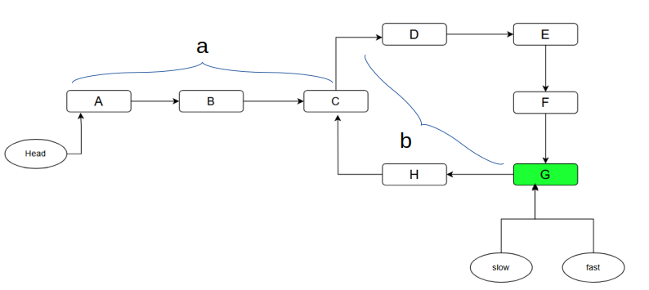
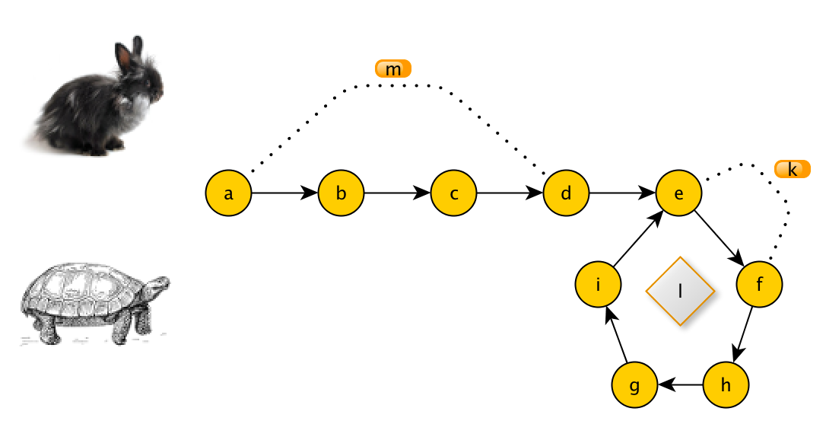

4
Use when problem mentions
- Middle of list
- Cycle detection
- Palindrome check
- Split list into halves
Core idea
- slow → 1 step
- fast → 2 steps
Classic Problems
- 876 — Middle of Linked List
- 141 — Linked List Cycle
- 142 — Cycle II (find start)
- 234 — Palindrome Linked List

🔵 Reversal Pattern
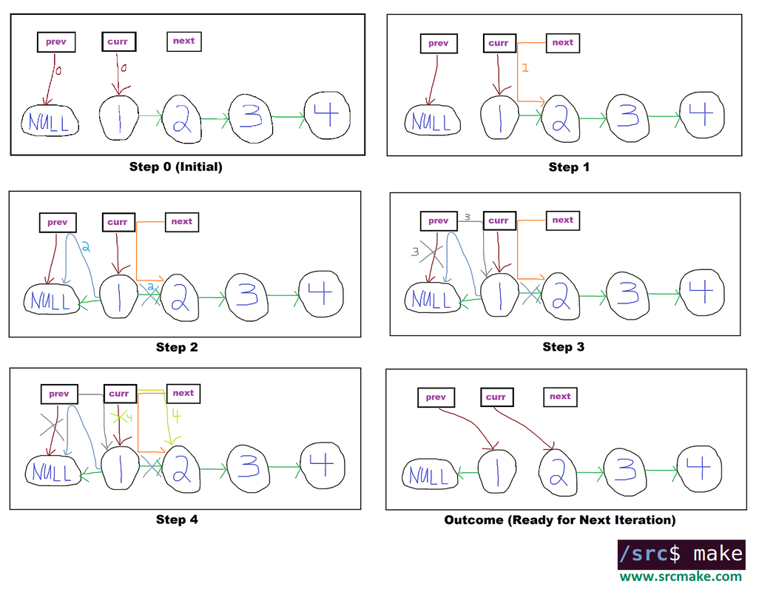
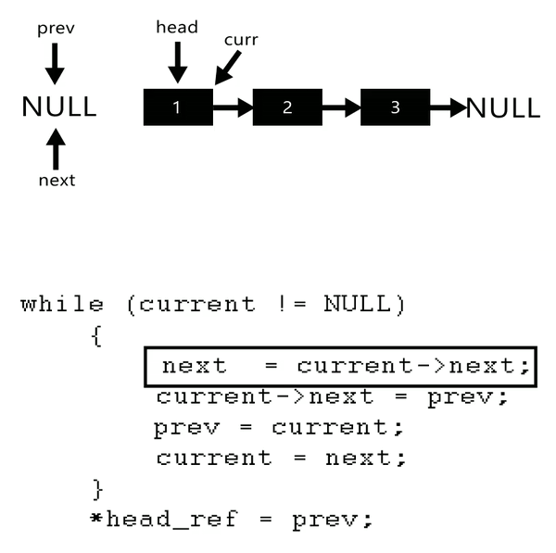
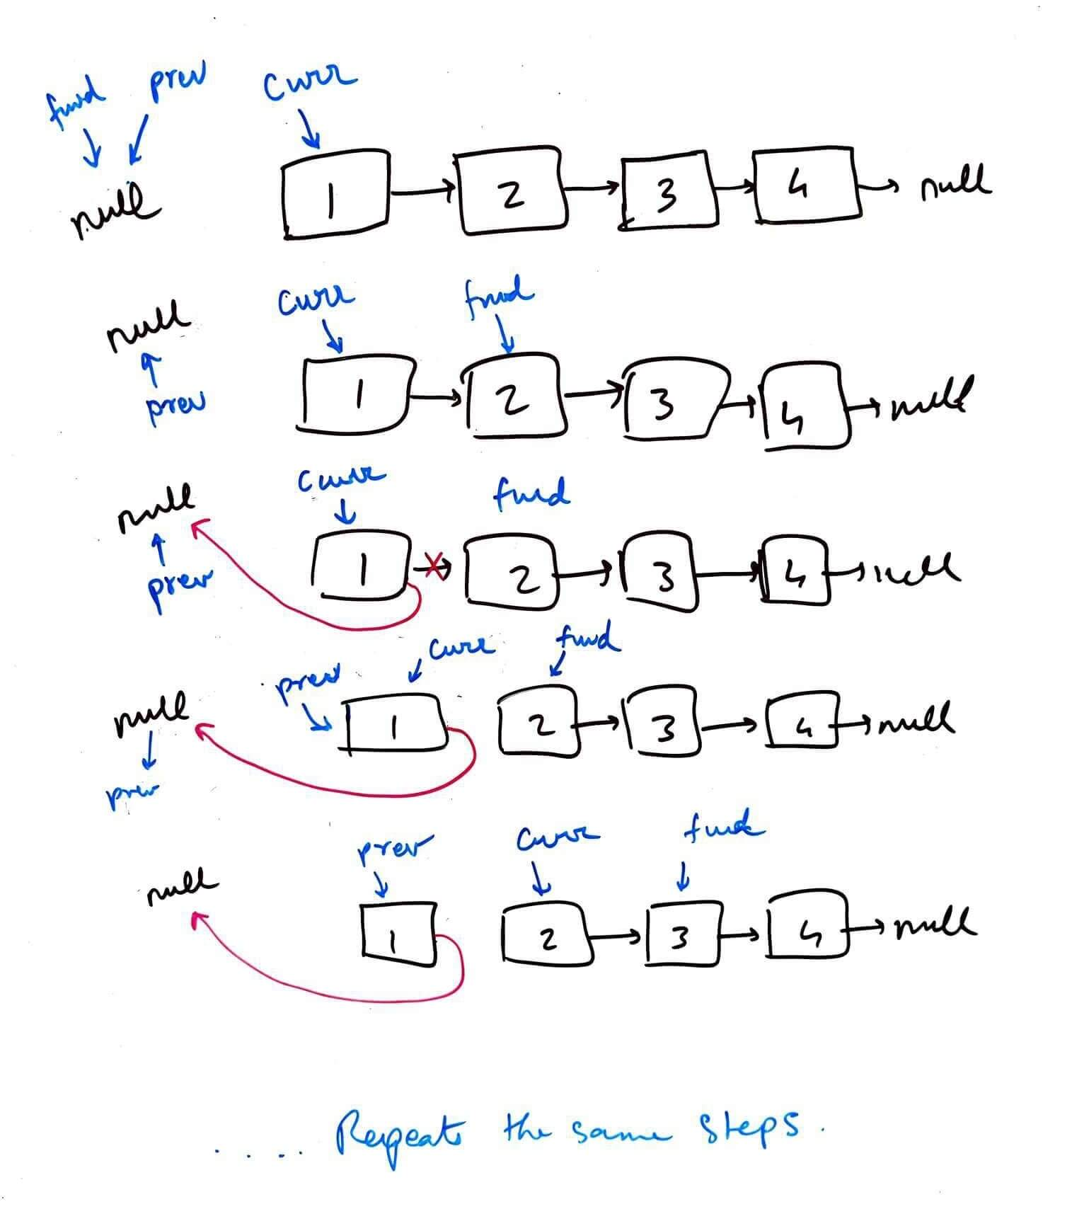
4
Use when problem says
- Reverse list / sublist
- Reverse in groups
- Reverse second half
Core idea
prev ← curr → next
Classic Problems
- 206 — Reverse Linked List
- 92 — Reverse Linked List II
- 25 — Reverse Nodes in k-Group

🟡 Dummy Node Pattern
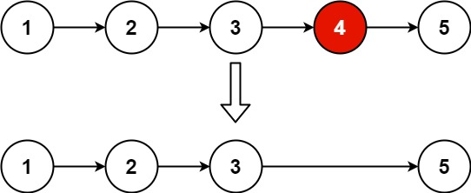

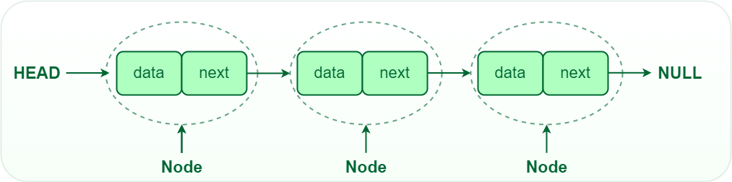
4
Use when
- Head may change
- Insertion/deletion at front
- Clean handling of edge cases
Core idea
Create fake head → operate → return dummy.next
Classic Problems
- 19 — Remove Nth From End
- 2 — Add Two Numbers
- 86 — Partition List
- 82 — Remove Duplicates II

🟣 Merge Pattern
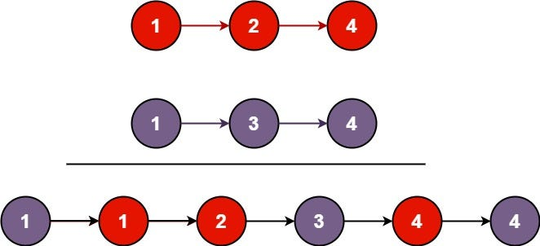
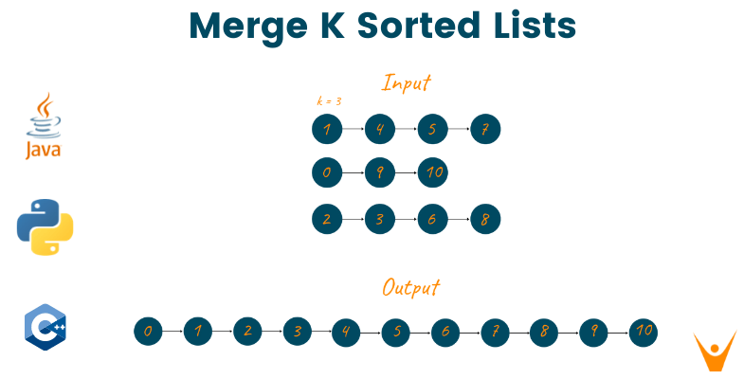
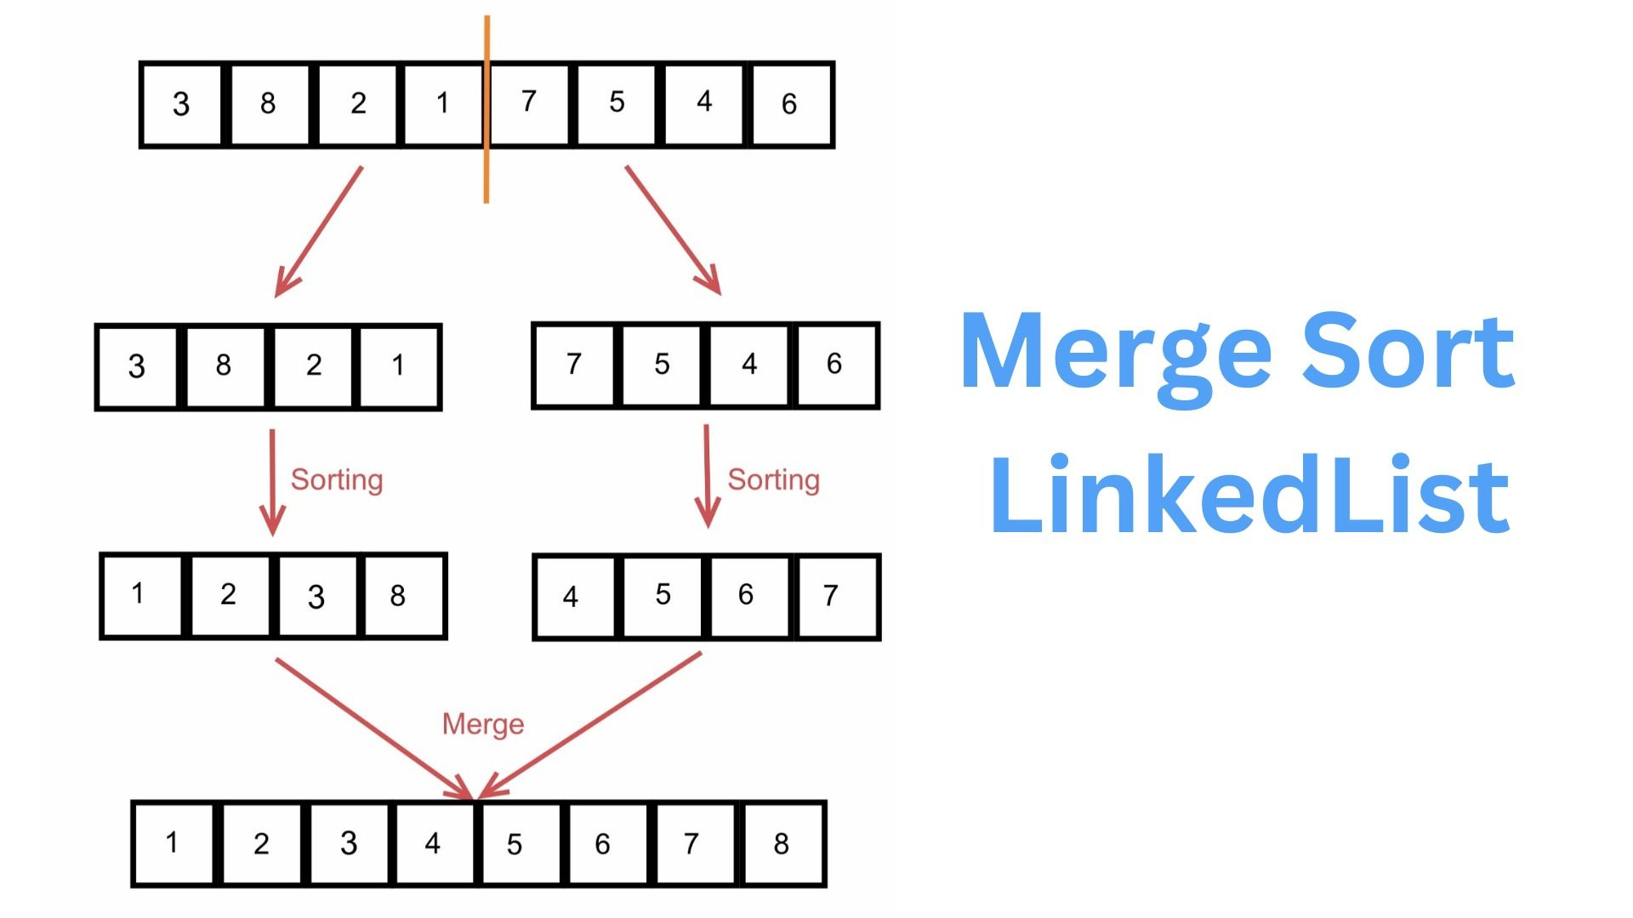
4
Use when
- Two sorted lists
- Combine multiple lists
- Sorting linked list
Core idea
Pick smaller node → advance that list
Classic Problems
- 21 — Merge Two Sorted Lists
- 23 — Merge k Lists
- 148 — Sort List

🔴 K-Pointer / Window on List
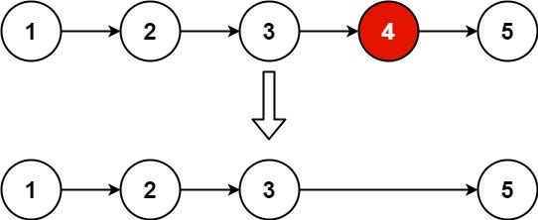
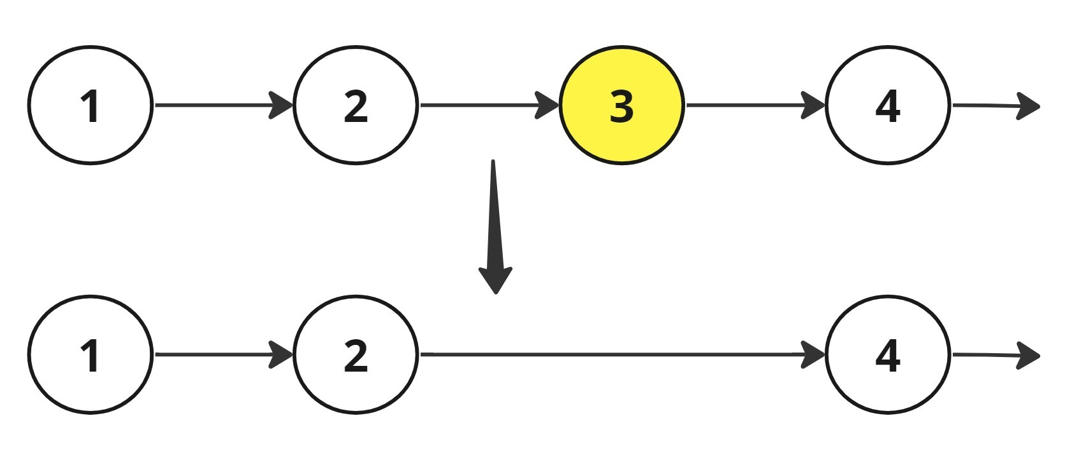

4
Use when
- Nth node from end
- K distance between pointers
- Rotate list
Core idea
Maintain fixed gap between pointers
Classic Problems
- 19 — Remove Nth From End
- 61 — Rotate List

⚫ Pointer Rewiring / Rearrangement
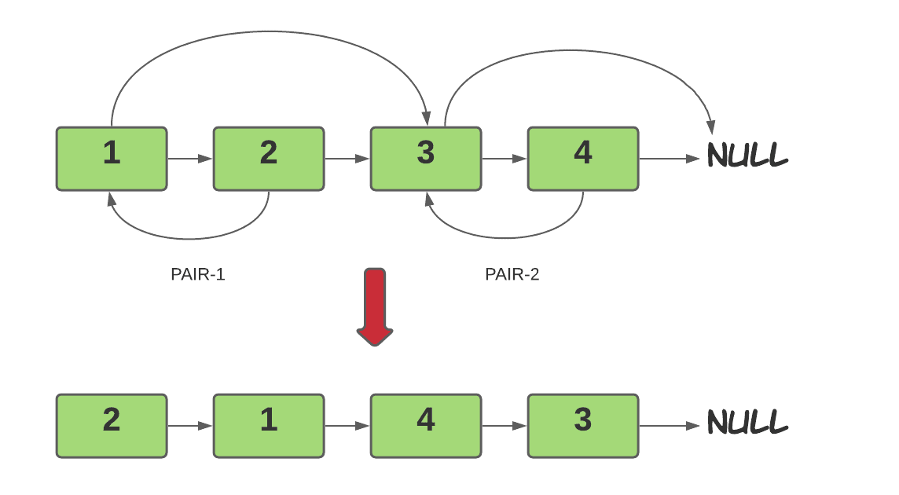
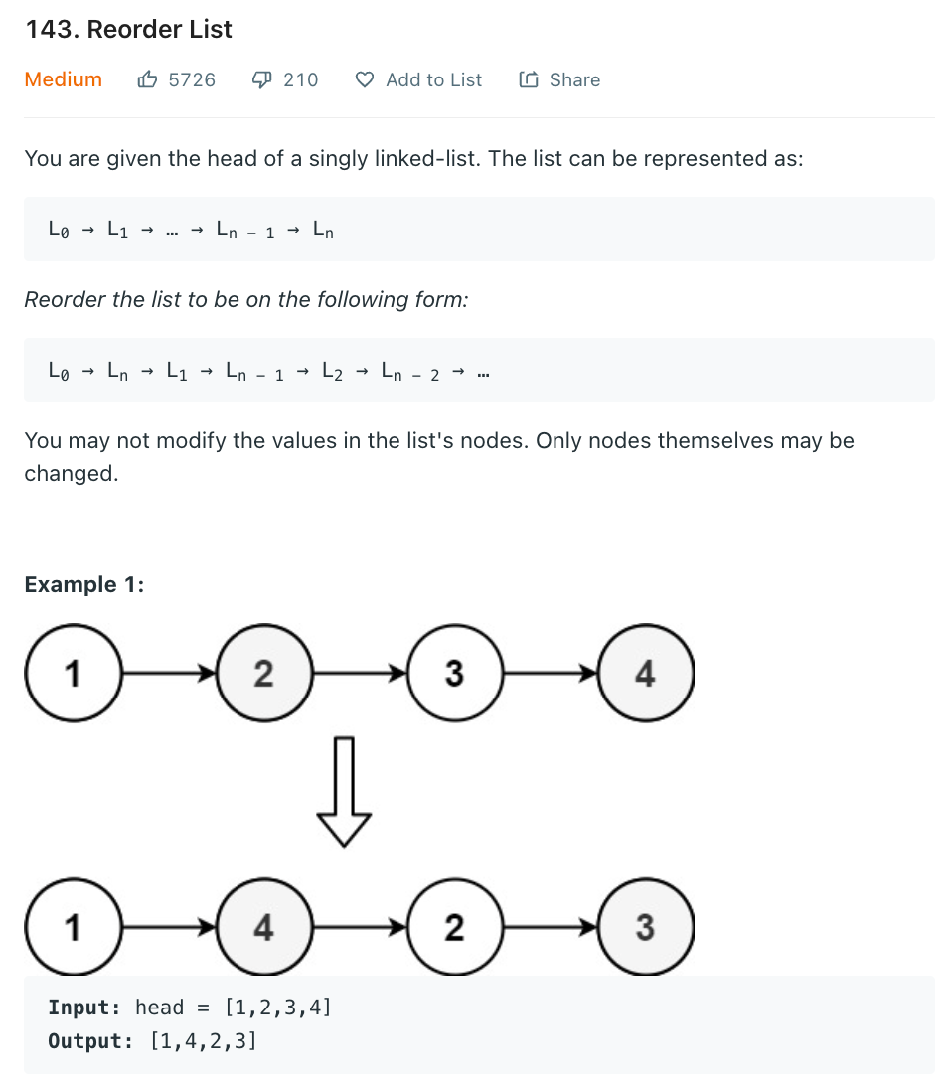
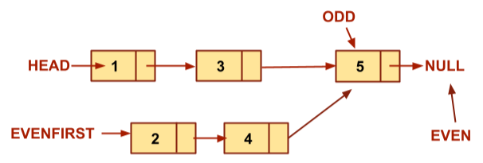
4
Use when
- Swap nodes
- Reorder structure
- Odd–even grouping
- Complex rearrangement
Classic Problems
- 24 — Swap Nodes in Pairs
- 143 — Reorder List
- 328 — Odd Even Linked List
- 445 — Add Two Numbers II

🧠 Ultra-Quick Decision Table
If question says… | Apply pattern
Middle / Cycle / Palindrome | Fast & Slow
Reverse / Partial reverse | Reversal
Head changes / clean ops | Dummy Node
Sorted lists combine | Merge
Nth from end / K gap | K-Pointer
Reorder / Swap nodes | Rewiring

🔗 Linked List — Complete Master Sheet (All Patterns + Java Templates)

🟢 1) Basic Traversal & Construction (Easy)
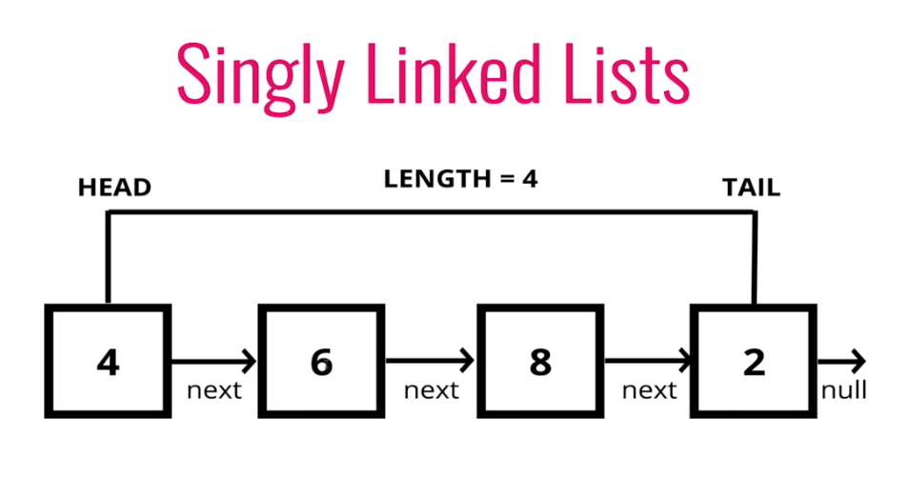
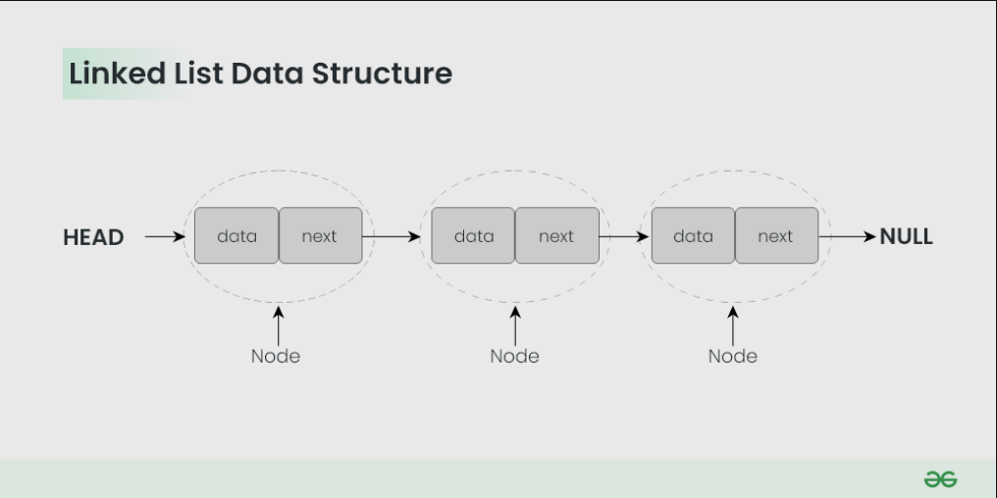
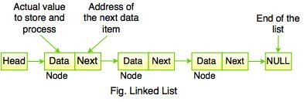
Use when: Iteration, counting, searching, simple deletion.
Template (Traversal)
ListNode curr = head;
while (curr != null) {
// process curr.val
curr = curr.next;
}
Length
int len = 0;
for (ListNode curr = head; curr != null; curr = curr.next) {
len++;
}

🟡 2) Fast & Slow Pointer (Tortoise–Hare)

4
Use for: Middle, cycle, palindrome, split list.
Template
ListNode slow = head, fast = head;
while (fast != null && fast.next != null) {
slow = slow.next;
fast = fast.next.next;
}
// slow = middle
Cycle Detection
while (fast != null && fast.next != null) {
slow = slow.next;
fast = fast.next.next;
if (slow == fast) return true;
}
return false;

🔵 3) Reversal (Full List)
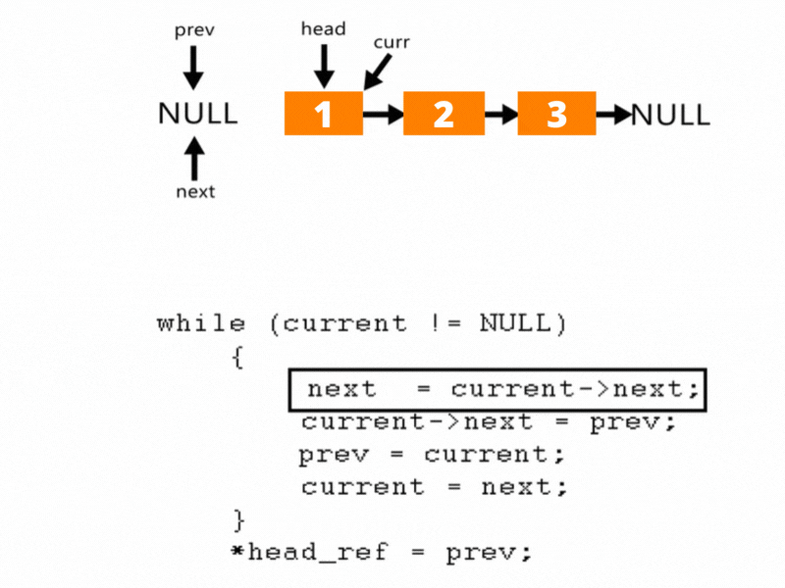
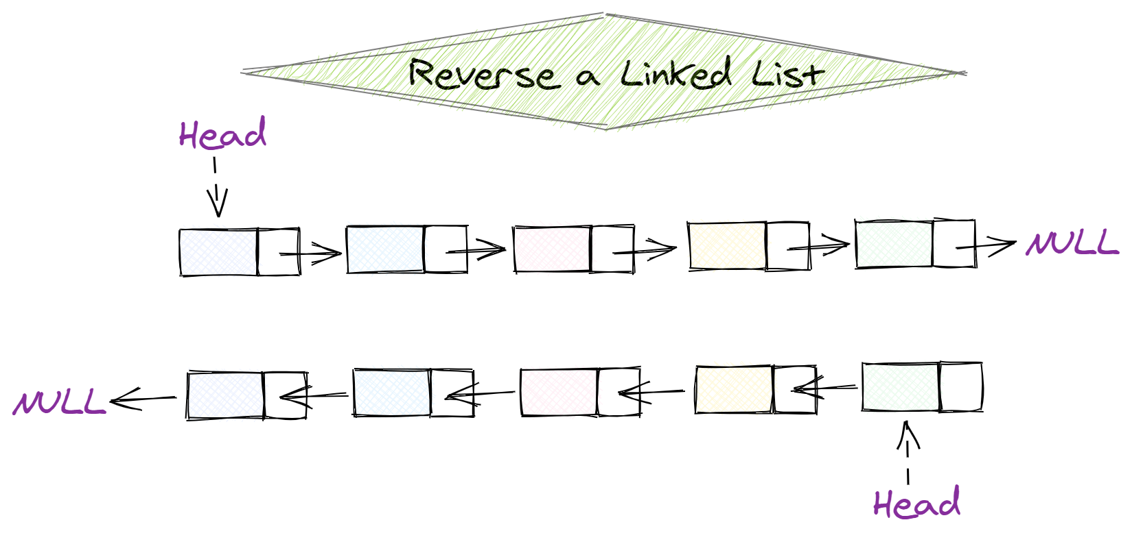
4
Use when: Reverse entire list.
Template
ListNode prev = null, curr = head;
while (curr != null) {
ListNode next = curr.next;
curr.next = prev;
prev = curr;
curr = next;
}
head = prev;

🟣 4) Reverse Sublist (Between Positions)
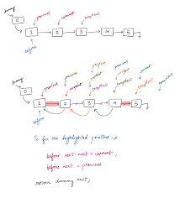
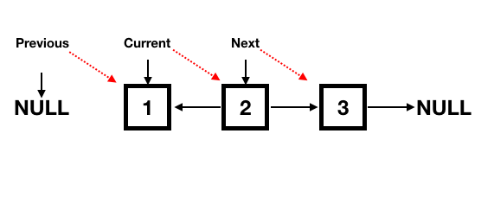
4
Use for: Reverse between left and right.
Template
ListNode dummy = new ListNode(0);
dummy.next = head;
ListNode prev = dummy;
for (int i = 1; i < left; i++) prev = prev.next;
ListNode curr = prev.next;
for (int i = 0; i < right - left; i++) {
ListNode next = curr.next;
curr.next = next.next;
next.next = prev.next;
prev.next = next;
}
return dummy.next;

🔴 5) Reverse in K-Group (Hard)
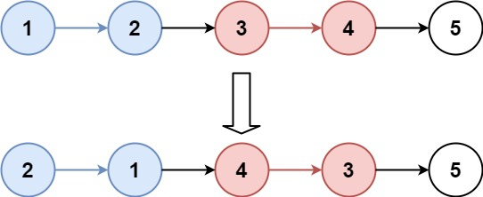
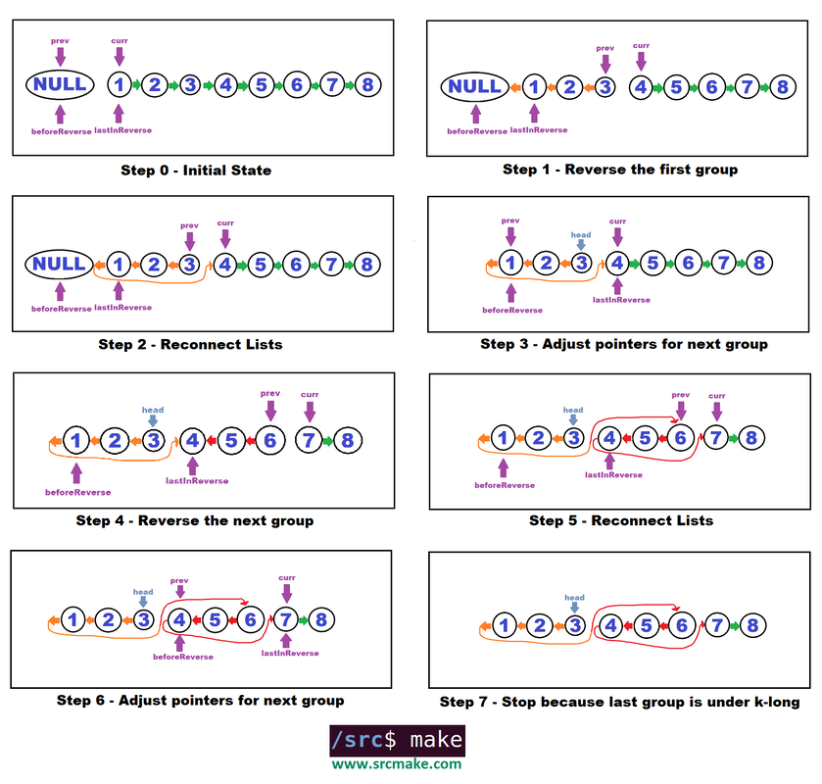
4
Use when: Reverse every k nodes.
Template (Core Logic)
public ListNode reverseKGroup(ListNode head, int k) {
ListNode curr = head;
int count = 0;
while (curr != null && count < k) {
curr = curr.next;
count++;
}
if (count == k) {
ListNode prev = reverseKGroup(curr, k);
while (count-- > 0) {
ListNode next = head.next;
head.next = prev;
prev = head;
head = next;
}
head = prev;
}
return head;
}

🟠 6) Dummy Node Pattern (Sentinel)
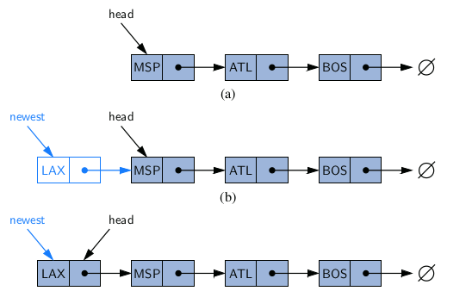
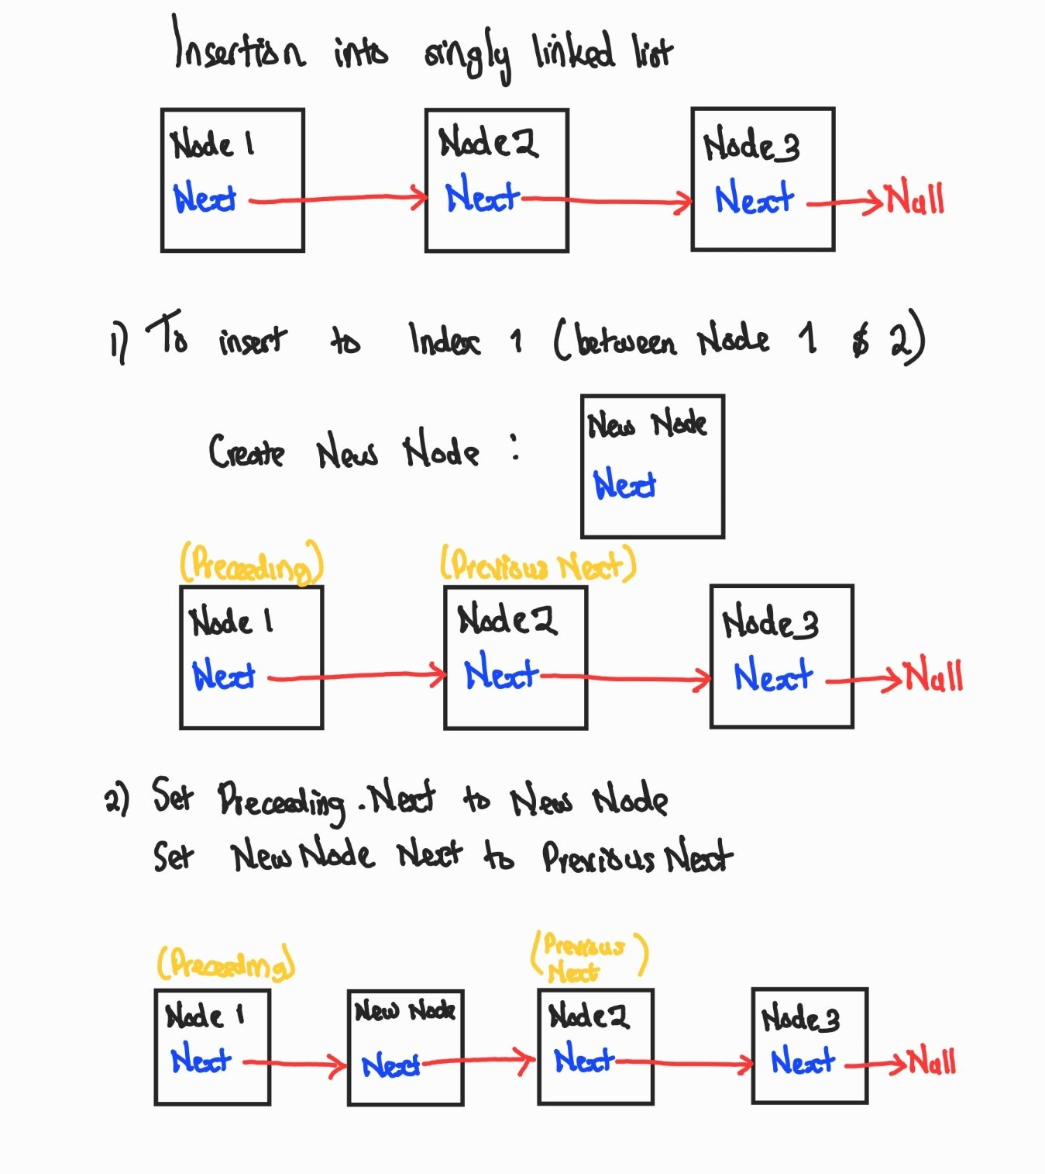
4
Use when: Head may change, insert/delete near front.
Template
ListNode dummy = new ListNode(0);
dummy.next = head;
ListNode prev = dummy;
ListNode curr = head;
// perform operations
return dummy.next;

🟤 7) Remove Nth Node From End (K-Gap)
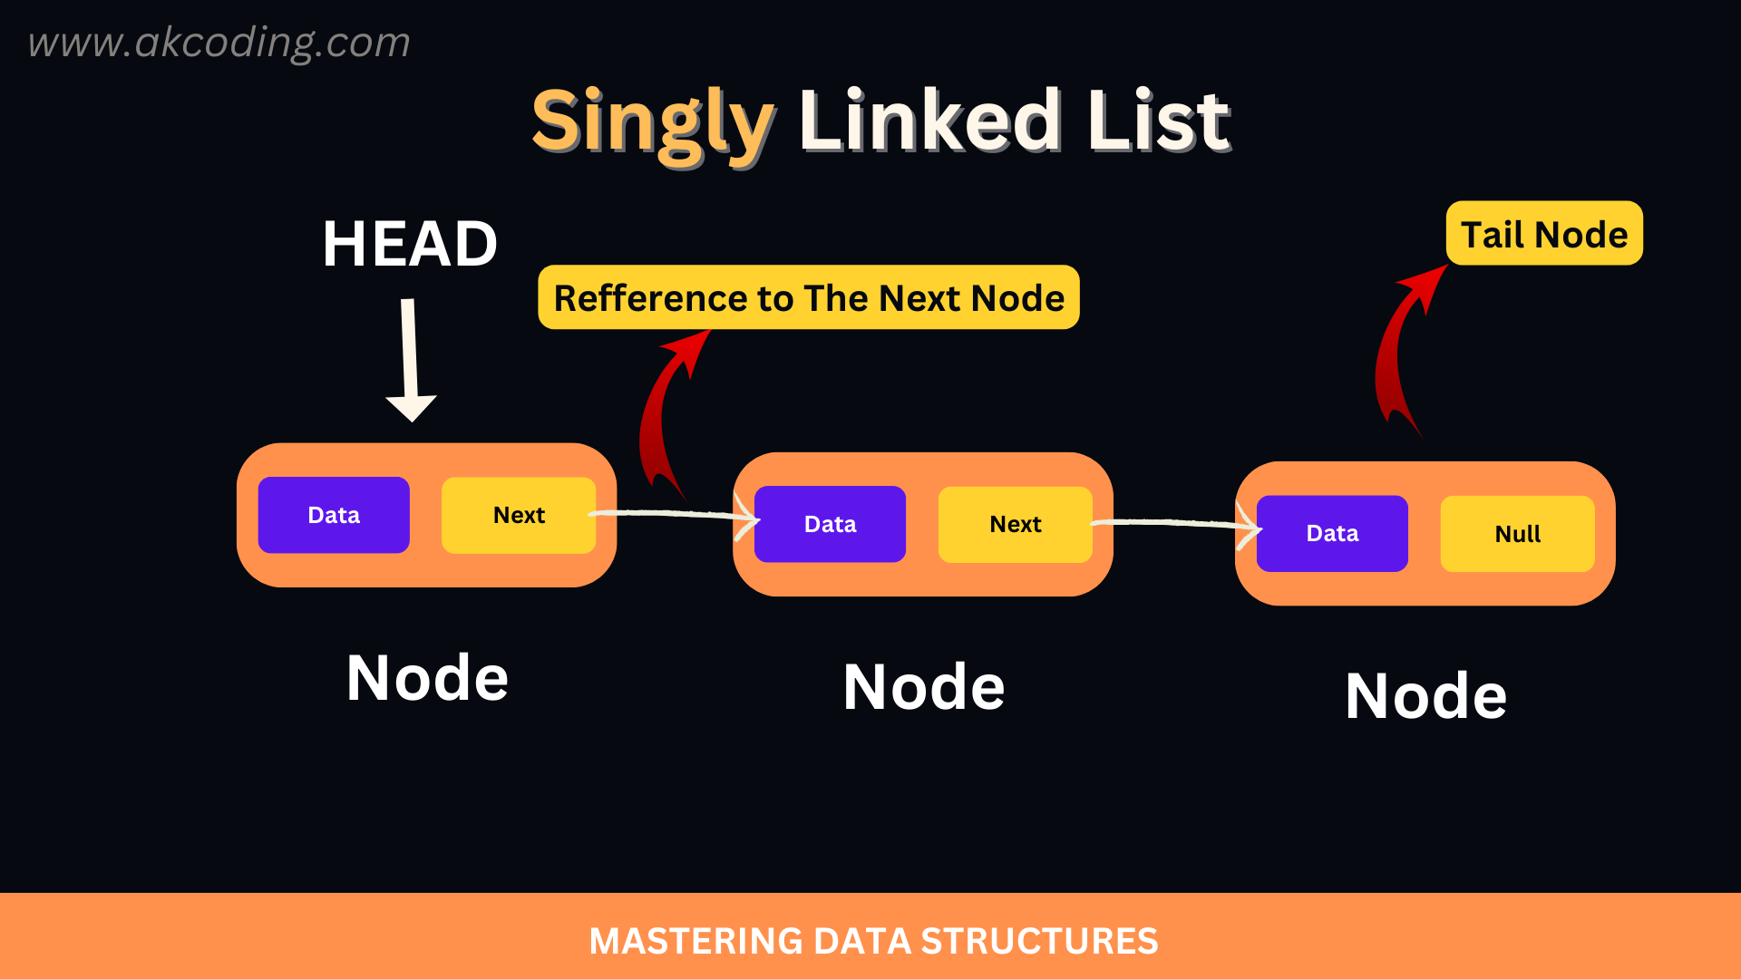
4
Use when: Nth from end, fixed distance pointers.
Template
ListNode dummy = new ListNode(0);
dummy.next = head;
ListNode fast = dummy, slow = dummy;
for (int i = 0; i <= n; i++) fast = fast.next;
while (fast != null) {
fast = fast.next;
slow = slow.next;
}
slow.next = slow.next.next;
return dummy.next;

🟢 8) Merge Two Sorted Lists
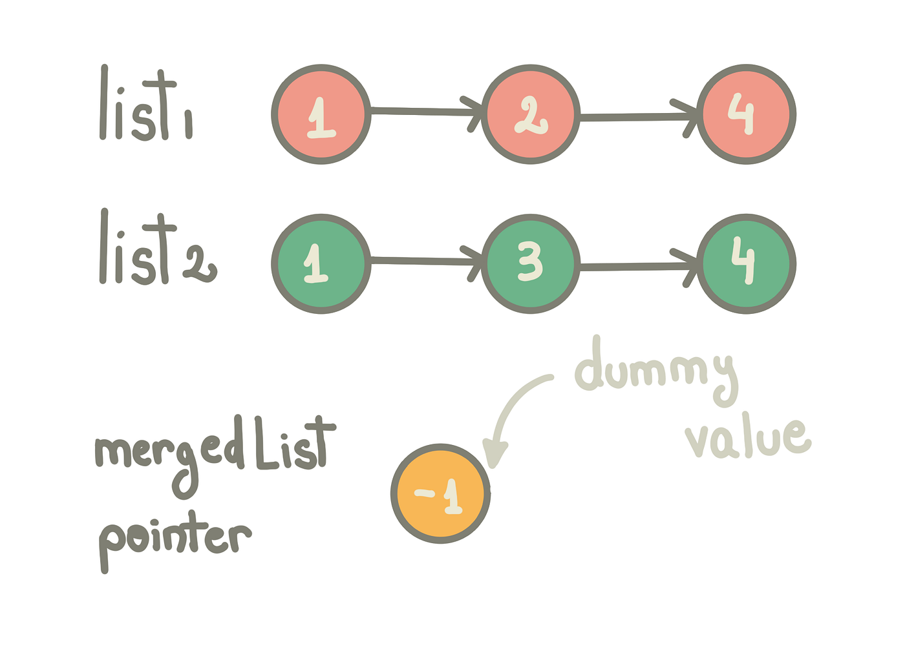
4
Template
ListNode dummy = new ListNode(0);
ListNode tail = dummy;
while (l1 != null && l2 != null) {
if (l1.val < l2.val) {
tail.next = l1;
l1 = l1.next;
} else {
tail.next = l2;
l2 = l2.next;
}
tail = tail.next;
}
tail.next = (l1 != null) ? l1 : l2;
return dummy.next;

🔵 9) Merge K Sorted Lists (Heap)
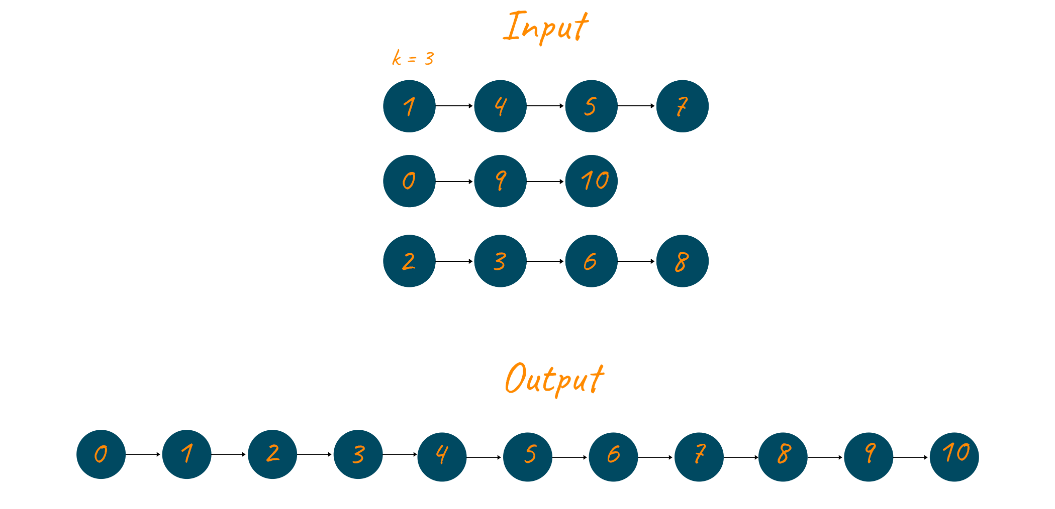
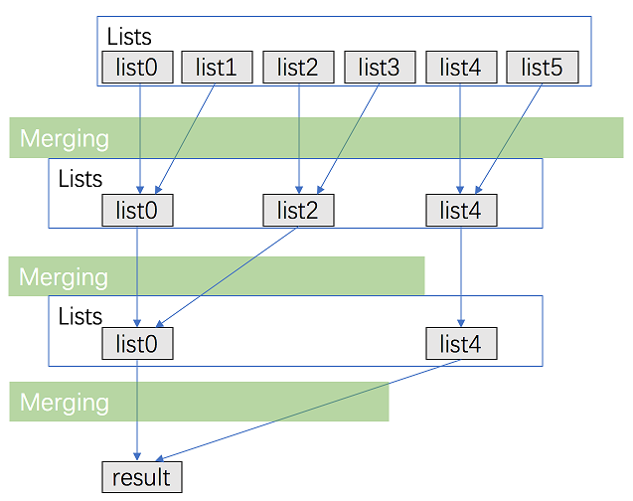
4
Template
PriorityQueue<ListNode> pq =
new PriorityQueue<>((a, b) -> a.val - b.val);
for (ListNode node : lists)
if (node != null) pq.add(node);
ListNode dummy = new ListNode(0), tail = dummy;
while (!pq.isEmpty()) {
ListNode node = pq.poll();
tail.next = node;
tail = tail.next;
if (node.next != null) pq.add(node.next);
}
return dummy.next;

🟣 10) Pointer Rewiring / Rearrangement
4
Use when: Swap, reorder, rotate, odd-even grouping.
Swap Pairs Template
ListNode dummy = new ListNode(0);
dummy.next = head;
ListNode curr = dummy;
while (curr.next != null && curr.next.next != null) {
ListNode first = curr.next;
ListNode second = curr.next.next;
first.next = second.next;
second.next = first;
curr.next = second;
curr = first;
}
return dummy.next;

🧠 Interview Pattern Decision Map
If question mentions… | Pattern
Middle / Cycle / Palindrome | Fast–Slow
Reverse whole/part | Reversal
Reverse in groups | K-Group
Head modifications | Dummy Node
Nth from end | K-Gap
Sorted lists combine | Merge
Complex rearrangement | Rewiring

